

**PROJECT REPORT ON**

**VEHICLE TRACKING SYSTEM**

*IN PARTIAL FULFILMENT OF  
TECH FOR SOCIETY BOOT CAMP ON ARDUINO*

**BY**

**TEAM ACHIEVERS**

**TEAM ACHIEVERS:**

1.A.V KUSUMITHA LAKSHMI

HT NO:20711A0405

ECE-A

2.G.SUVARCHALA

HT NO:20711A0440

ECE-A

3.D.CHANDI PRIYA

HTNO:20711A0429

ECE-A

4.LIKITHA

HTNO:20711A04H2

ECE-C

5.Y.PRASHANTH

HTNO:20711A04J1

ECE-C

6.K.SUNIL

HTNO:20711A0469

ECE-B

**PROBLEM:**

As a part of the workshop, we have visited a village named T.P Gudem.They mentioned a problem about the public transportation especially Bus.The Bus is not coming into the village.It being a major issue for the students who are going to town for schools,colleges etc., and also for emergency purposes.

**WHY TO SOLVE?**

This is a major problem in that village.It effects the Students.My team members are also facing the same problem.Due to the lack of buses,the people are necessarily needs to prefer autoes for their Daily works.It costs Minimum 60 rupees per day.The people in those village are mainly daily wage workers.60 rupees for auto per day is a very big thing for the people.So we wants to solve this problem as possible for us.

**HOW TO SOLVE THIS PROBLEM?**

To solve this problem we have to invent a system that provides a signal from bus as it is outside of the village and the signal have to be communicate with the people inside the village.By receiving the signal from the bus, the people inside the village who wishes to travel in that bus have to communicate with the driver.

* To establish this system,we need the following components:

1.Arduino

2.Bread Board

3.Buzzer

4.IR Sensor

5.LED

6.Buzzer

7.Jack Wires/Connecting Wires

**WORKING PROCESS:**

The IR Sensor is placed at the outside bus-stop of the village. When the bus is detected ,it makes a buzzer sound into the village.When there are passengers,they have to on the switch which is placed at the bus stop into the village.The switch into the village bus stop makes the led to glow at the bus stop which is at outside of the village which indicates to the bus driver that there are passengers in the village.Then the bus goes into the village.If there are no passengers in the village,the bus no need to go into the village.This reduces the time waste,petrol and diesel waste.By this system the problem for the people can be solved.This system is simple to design,low cost of maintainance and beneficial to the villagers.

**PICTORIAL DIAGRAM:**

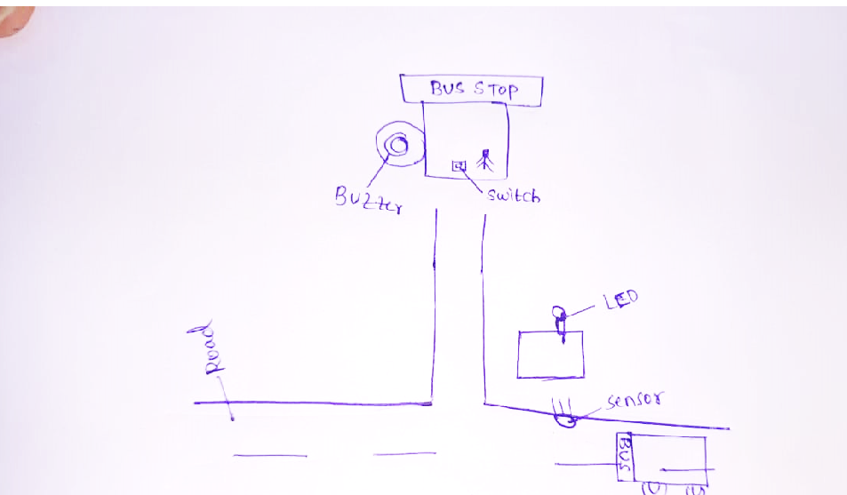

**CIRCUIT DIAGRAM:**

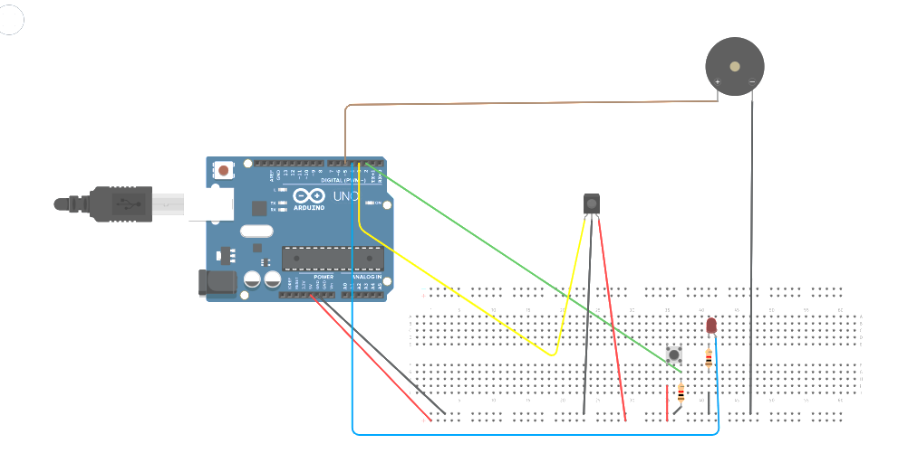

**CODE :**

int swh_pin = 2;

int pir_pin = 3;

int led_pin = 4;

int buz_pin = 5;

void setup()

{

Serial.begin(9600);

pinMode(swh_pin,INPUT);

pinMode(pir_pin,INPUT);

pinMode(led_pin,OUTPUT);

pinMode(buz_pin,OUTPUT);

}

void loop()

{

int switch_val = digitalRead(swh_pin);

int pir_val = digitalRead(pir_pin);

Serial.print("push button: ");

Serial.println(switch_val);

Serial.print("motion sensor: ");

Serial.println(pir_val);

if(pir_val==0)

digitalWrite(buz_pin,HIGH);

else

digitalWrite(buz_pin,LOW);

if(switch_val==1)

digitalWrite(led_pin,HIGH);

else

digitalWrite(led_pin,LOW);

delay(500);

}

**PHOTO:**

